17.68: a) From Eq.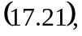

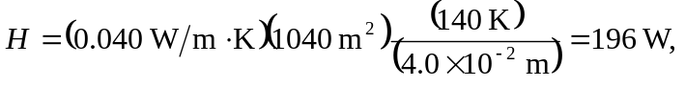
or 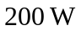to two figures. b) The result of part (a) is the needed power input.

